EVAN BROWN UV WNWRAPPING
https://github.com/EvanBrown-Git/Essentials/blob/main/DAGV1100and1200/Maya/scenes/Diorama/Diorama13.ma
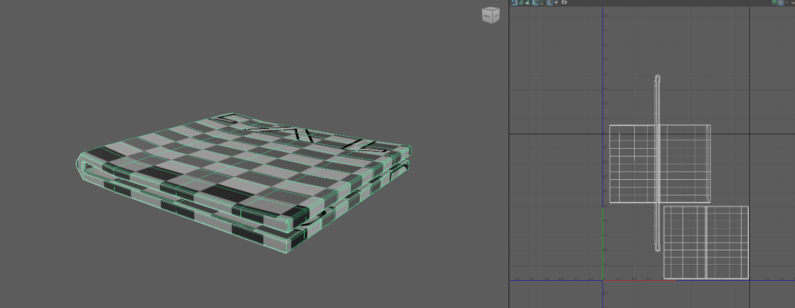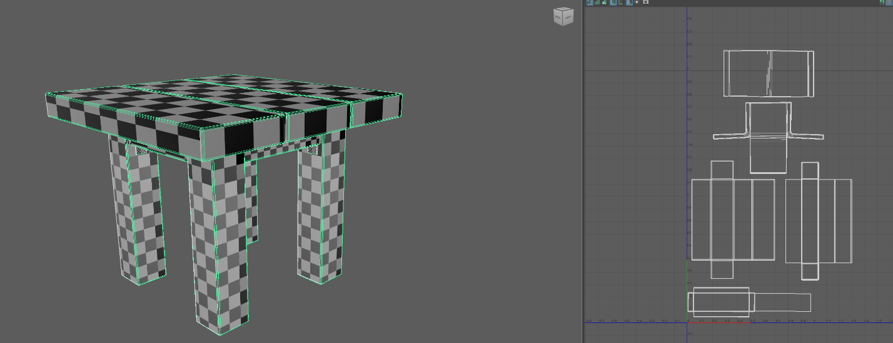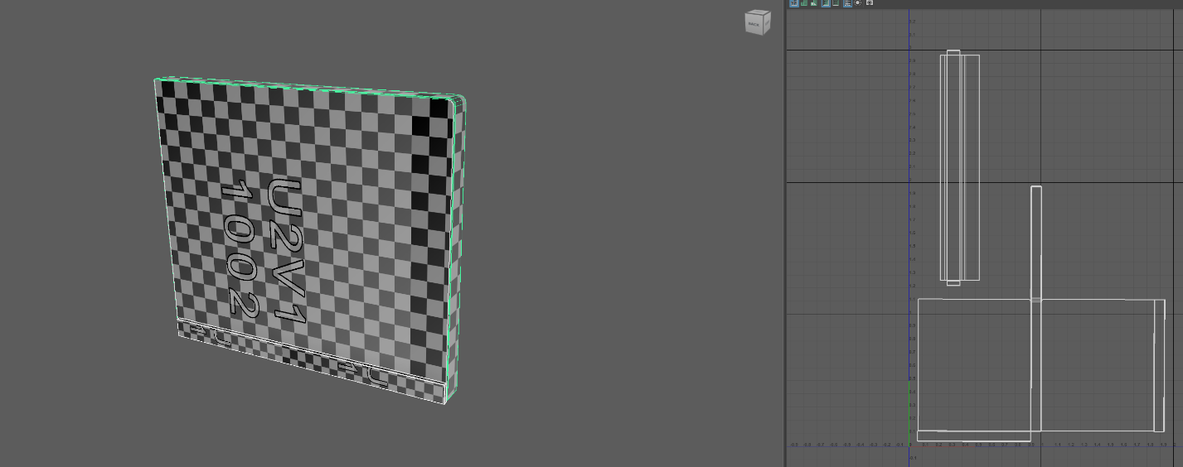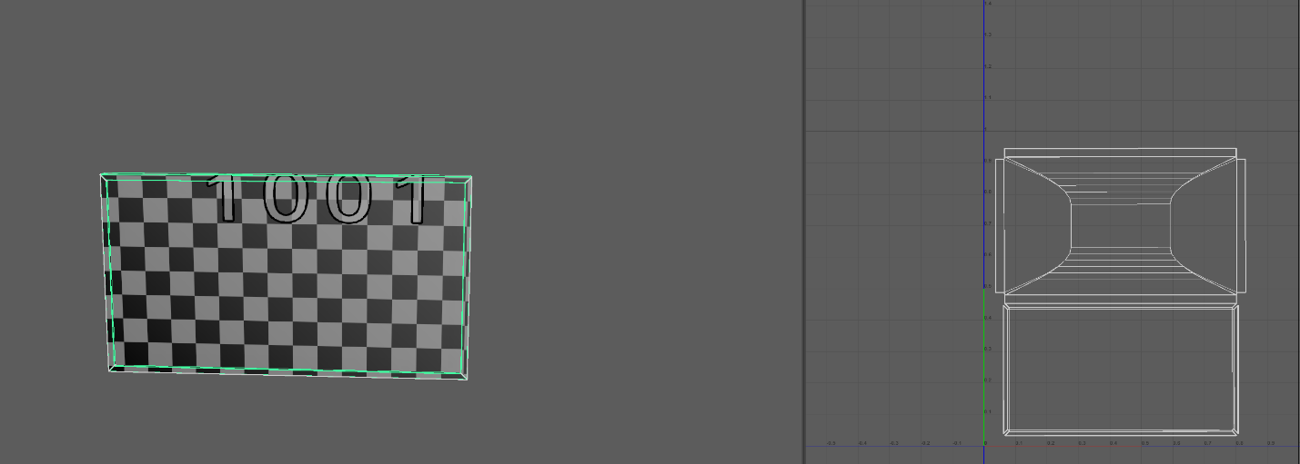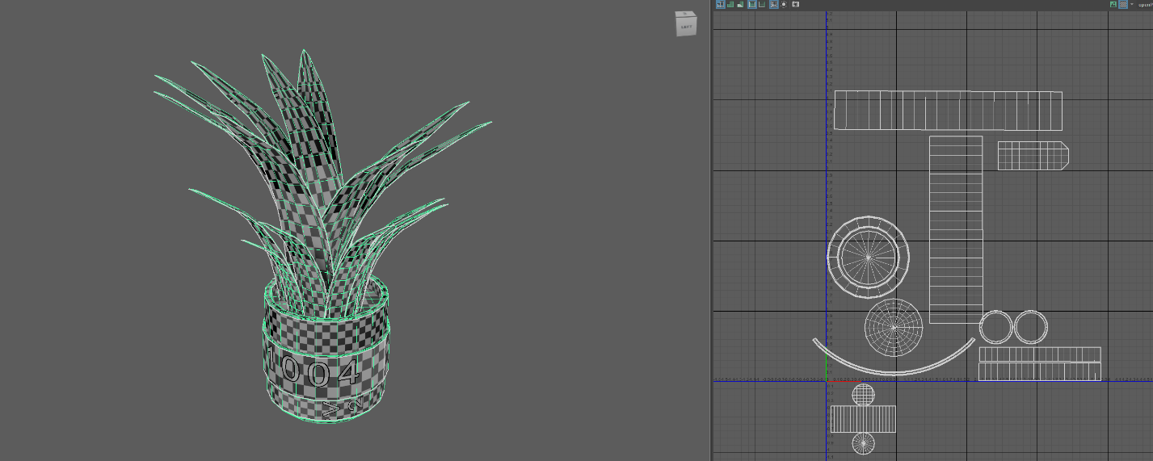

I started by trying to cut and sew carefully, but then I switched to sewing everything, then selecting where the seams would be and cutting. I used the stitch together tool to resize and connect the shells. I had a lot of trouble near the beginning because I kept trying to use the UV projectors but I realized that doing it manually with more complex objects (like the L Brackets on the table) was far easier.

